RA Requirements for Multi-Agent Research Web Interface
1. Goal
Build a web interface on top of the existing Python multi-agent simulation codebase for two types of studies:
- Pure AI Teams — simulations in which all team members are AI agents.
- AI Teams with Human-in-the-Loop — experiments in which a human participant observes and interacts with an AI team.
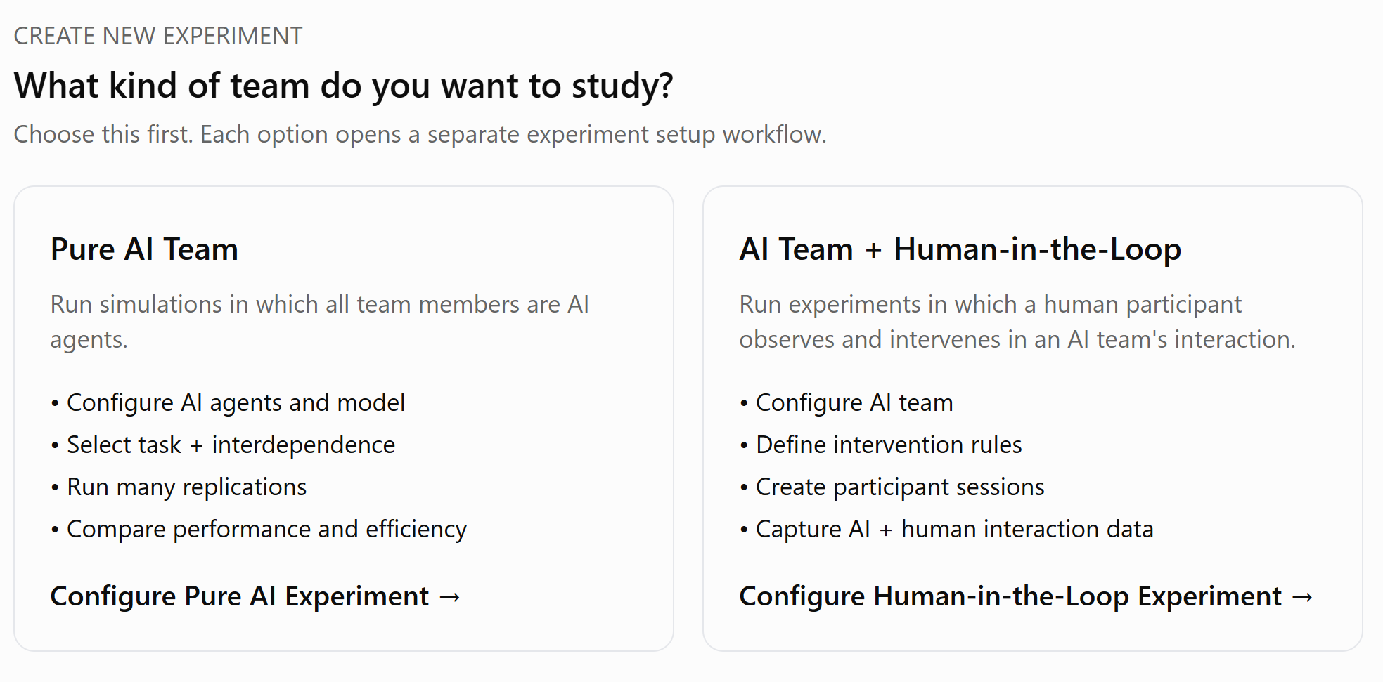
The web application should call the existing Python codebase rather than reproduce simulation logic in the front end.
(The code base is adapted from: https://github.com/apappu97/multi-agent-teams-hold-experts-back, for paper: Multi-Agent Teams Hold Experts Back (arXiv:2602.01011) - A toolkit for multi-agent LLM teamwork experiments)
The project should support the four interdependence structures specified in the current research plan—pooled, sequential, reciprocal, and team—and save task scores, token usage, and conversation transcripts. Most of the data storing steps are implemented in the existing Python codebase.
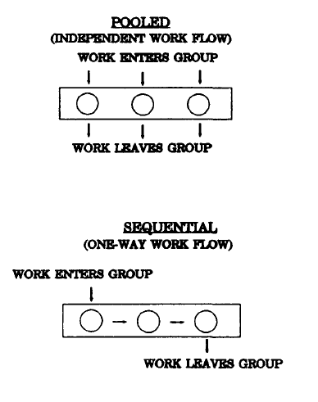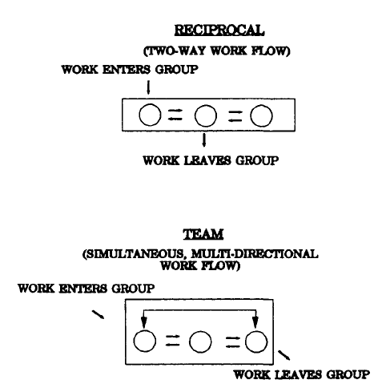
Source: Saavedra, R., Earley, P. C., & Van Dyne, L. (1993). Complex interdependence in task-performing groups. Journal of applied psychology, 78(1), 61.

2. First Step: Choose Experiment Type
On the landing page, the researcher creates a new experiment. The first choice is:
Option A — Pure AI Team
AI agents complete the task without human participation.
Option B — AI Team + Human-in-the-Loop
A human participant observes the AI team and can intervene during the interaction.
These should lead to two separate researcher configuration pages/workflows.
The two workflows can share backend components such as:
- tasks;
- LLM configuration;
- agent configuration;
- interdependence structures;
- scoring;
- data storage.
However, participant and intervention settings should appear only in the Human-in-the-Loop workflow.

3. Researcher Page A: Pure AI Team
The researcher should be able to configure:
LLM
- LLM provider / model
- API credentials
- temperature (and other model parameters? -- PENDING)
Task
- select an existing task from the Python codebase; or
- provide a custom task, with the custom task provided by the researcher [PENDING: What format? Could be a Python script added in the same folder as other existing tasks or type directly to a textbox as a prompt]
For existing tasks, provide a description of the task.
For custom tasks, distinguish between:
- Unscored task — prompt only
- Scored task — prompt plus scoring method/ground truth [PENDING: Do we support custom scored tasks? We can just ask the researchers to download the data and analyze themselves…]
AI Team
- number of AI agents
- interdependence structure:
  - pooled
  - sequential
  - reciprocal [PENDING: Need to figure out how reciprocal structure is constructed in the bendend]
  - team
- number of discussion rounds
- other team settings supported by the Python codebase
Simulations
- number of replications
- random seed, if desired [PENDING: Not sure if random seed matters]
Before launching, show the researcher a summary of the configuration.
The researcher then clicks:
Start Experiment

4. Researcher Page B: AI Team + Human-in-the-Loop
This page should contain the same core AI-team configuration:
- LLM provider/model
- Task
- AI Team

It will not have the Simulation configurations.
It should then include a separate section for Human Intervention Settings.
The researcher should configure:
When can the participant intervene? [PENDING: This component depends on what the Python backend can provide]
Examples:
- between any AI-agent turns;
- between discussion rounds;
- only at predefined intervention points.
Who receives the intervention?
Examples:
- all AI agents;
- next AI agent;
- selected agent.
How is the intervention presented to the AI?
Examples:
- human teammate message;
- system instruction;
- user message.
Intervention limits [PENDING: Not sure if this component is necessary]
Optional settings:
- unlimited interventions;
- maximum number of interventions;
- intervention only during selected rounds.
Participant instructions
Allow the researcher to enter the instructions shown to participants before the experiment begins.
Participant sessions [PENDING: need to figure out how this works, if participants and researchers are using the same computer]
The system should generate participant/session links or codes.
Participants should not need researcher accounts.

5. Running Experiments
Experiments should run on the server side, not depend on the browser remaining open.
For Pure AI simulations, show progress such as:
47 / 100 simulations completed
Also show:
- running;
- completed;
- failed;
- cancelled.
For Human-in-the-Loop studies, show participant-session status such as:
- not started;
- active;
- paused;
- completed;
- disconnected;
- terminated.
Errors should be saved rather than causing completed data to disappear.

6. Researcher Results Dashboard
After or during an experiment, researchers should see a simple dashboard.
At the top of the page, provide two clear buttons:
Download Data
View Individual Runs/ Sessions
The dashboard shows the following statistics, which will be returned by the Python backend (do not need JavaScript to calculate them).
Performance
For scoring tasks with the right answer, show:
- mean score
- median
- standard deviation
- minimum/maximum
- score distribution
Efficiency
Show:
- input tokens
- output tokens
- total tokens
- conversation turns
- run duration
Reliability
Show variation in performance across repeated simulations.
The dashboard should provide quick descriptive results rather than attempt to replace statistical analysis in R/Python/Stata.

7. Individual Run / Session Viewer
Researchers should be able to open any individual run or participant session. This data can be accessed from a json or csv file.
Display:
- task
- model
- number of agents
- interdependence structure
- rounds
- final answer
- task score
- token usage
- full conversation transcript
Clearly label messages from:
- Agent 1
- Agent 2
- Agent 3, etc.
- Human Participant
- System
For Human-in-the-Loop studies, human messages must remain clearly distinguishable from system prompts.

8. Participant Interface
The participant-facing page should be simple and separate from the researcher interface.
Start
Participant opens a unique session link and sees:
- experiment instructions
- Begin button
Use participant/session IDs rather than names whenever possible.
Observe AI Team
Display the AI team's conversation as it happens, paced for human readers such that the participant has enough time to read and respond.
Show:
- speaker
- message
- current round
- whether the team is running or paused
New AI messages should appear without requiring a page refresh.
Pause
Provide:
Pause Team
Pause should happen at a safe boundary. If an LLM request is already running, it may finish, but the system should not begin another AI turn.
Intervene [PENDING: the possible interventions will depend on what the backend looks like]
When paused, the participant can type:
- instructions;
- clarification;
- new information;
- questions;
- corrections;
- suggestions.
Then click:
Send to Team
Send to Agent 1
Send to Agent 2
Send to Agent 3
Etc.
The human message should appear in the conversation.
Resume
Provide:
Resume Team
The AI team should continue from the existing conversation rather than restart.
Completion
At the end:
- save the final team answer;
- save the score;
- save all messages;
- mark the session complete;
- show a completion screen.
Refreshing or temporarily disconnecting should not restart or erase the participant's session.

9. Data to Save (not reviewed yet)
Data collection is a core requirement.
For every run/session, save:
- experiment ID
- condition ID
- run/session ID
- participant ID, if applicable
- task
- task version
- interdependence structure
- number of AI agents
- LLM provider
- exact model
- model parameters
- seed
- timestamps
- final answer
- task score
- input tokens
- output tokens
- total tokens
- conversation turns
- errors/retries
- code version
For every message, save:
- run/session ID
- timestamp
- round
- turn
- speaker type
- speaker ID
- complete message text
For every human intervention, additionally save:
- exact intervention text
- timestamp
- round
- preceding AI turn
- subsequent AI turn
- pause duration
- which agents received the intervention
- how the intervention was presented to the LLM

10. Data Download
Provide a clear:
Download Data
button.
Recommended export:
- runs.csv
- messages.csv or messages.jsonl
- human_interventions.csv
- config.json
Researchers should be able to download the complete raw dataset, not only dashboard summaries.
API keys must never appear in downloadable files.

11. Backend Architecture
Recommended structure:
Researcher / Participant Browser
→ Web Backend / API
→ Existing Python Simulation Code
→ LLM Provider
The backend should manage:
- experiment configuration;
- simulation jobs;
- participant sessions;
- pause/resume;
- interventions;
- persistent storage;
- results;
- data export.
The server, not browser JavaScript, should maintain the authoritative experiment/session state.

12. Security
At minimum:
- researcher login
- researcher/participant role separation
- secure API-key handling
- API credentials not stored
- HTTPS in deployment?
- participant-session isolation
- server-side input validation
Participants must never be able to access:
- researcher controls;
- other participant sessions;
- API credentials;
- hidden experimental information;
- downloadable research datasets.

13. Important Decisions the Research Team Must Make
- When may participants intervene?
- Who receives a participant's intervention?
- Does the LLM see it as a system instruction, user message, or human teammate message?
- Does a human intervention count as a conversational turn?
- What happens immediately after an intervention?
- Can participants see all AI-agent communication?
- Can participants terminate the experiment early?
These choices affect the experimental treatment and therefore should be decided by the research team.

14. MVP Acceptance Criteria
Pure AI Team
The researcher can complete:
Choose Pure AI → Configure → Run Simulations → Monitor → View Results → Inspect Transcript → Download Data
without using Python or the command line.
AI Team + Human-in-the-Loop
The researcher can complete:
Choose Human-in-the-Loop → Configure AI Team → Configure Intervention Rules → Create Participant Session
and the participant can complete:
Enter → Observe → Pause → Intervene → Resume → Complete
with the complete AI-human interaction saved for later analysis.

Guiding Principle
Treat the application as a research instrument, not simply as a chatbot interface.
Priority order:
experimental control → complete data capture → reproducibility → reliable export → ease of use → visual polish

The Local Client-Server Application Design
Researcher's computer

┌─────────────────────────────────────────────┐
│ Browser │
│ http://localhost:8000 │
│ │
│ HTML / CSS / JavaScript │
└──────────────────┬──────────────────────────┘
│ HTTP / WebSocket
▼
┌─────────────────────────────────────────────┐
│ Local Python web server │
│ FastAPI │
│ │
│ • experiment configuration │
│ • run simulations │
│ • pause/resume │
│ • human interventions │
│ • save results │
└──────────────────┬──────────────────────────┘
│ Python calls
▼
┌─────────────────────────────────────────────┐
│ Multi-agent Python codebase │
│ │
│ Tasks → Agents → Interdependence → Scoring │
└──────────────────┬──────────────────────────┘
│
▼
LLM API / local LLM

A GitHub repository could look like this:
multi-agent-team-research/
│
├── teamwork/ # Existing Python package
│ ├── agents/
│ ├── tasks/
│ ├── backends.py
│ ├── interdependence/
│ └── ...
│
├── experiments/ # Existing simulation scripts
│ ├── run_lost_at_sea.py
│ ├── run_hiring.py
│ └── ...
│
├── webapp/
│ ├── app.py # FastAPI server
│ │
│ ├── static/
│ │ ├── css/
│ │ │ └── style.css
│ │ └── js/
│ │ ├── researcher.js
│ │ └── participant.js
│ │
│ └── templates/
│ ├── index.html
│ ├── pure_ai.html
│ ├── human_ai.html
│ ├── participant.html
│ └── results.html
│
├── data/ # Local results
│
├── tests/
│
├── .env.example
├── requirements.txt
├── pyproject.toml
├── README.md
└── LICENSE

Researcher's experience
Ideally they would do only:
git clone ...
cd multi-agent-team-research

python -m venv .venv
pip install -e .

python -m webapp.app
Then the terminal says:
Multi-Agent Research Interface

Open your browser:

http://localhost:8000
They visit that address and see:
Create New Experiment

┌─────────────────────────┐
│ PURE AI TEAM │
│ │
│ Run AI-only simulations │
│ │
│ Start → │
└─────────────────────────┘

┌─────────────────────────┐
│ AI + HUMAN-IN-THE-LOOP │
│ │
│ Run participant studies │
│ │
│ Start → │
└─────────────────────────┘
Everything after that happens through the browser.

